Windows Server Home Lab Project

4. Setting up File Sharing within the Active Directory.

The objective of the file sharing is to make the file sharing, contributing and modifying files easier.

Two types of networks sharing local and network sharing.

We have read, write, execute and full control permissions in this file sharing.

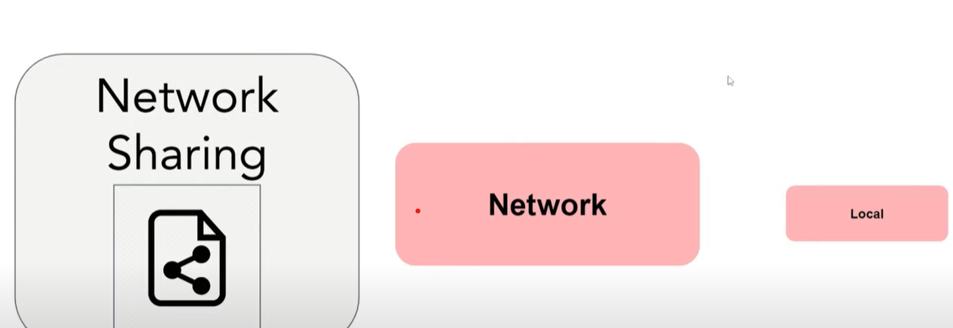

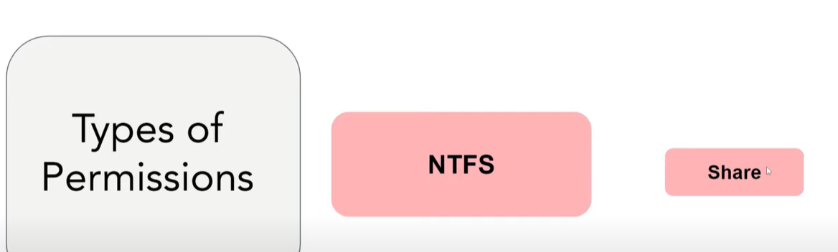 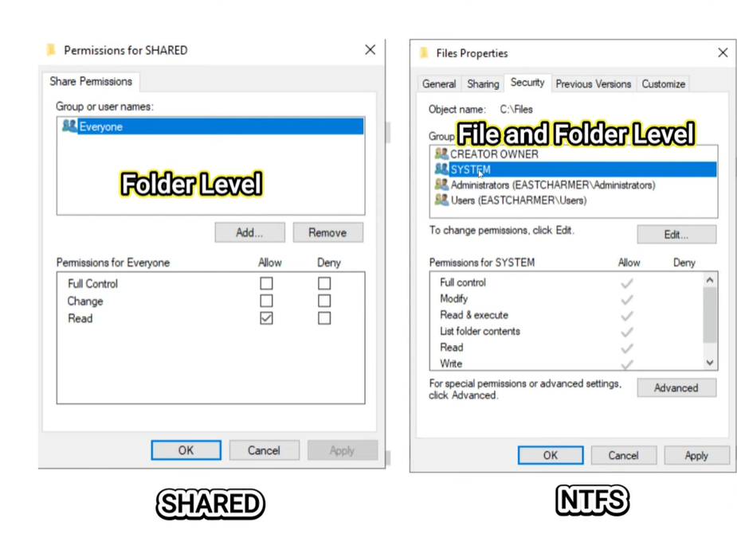NTFS at file, folder and sub folder level, shared at folder level only.



Now let’s start with creating a folder in our windows servers file explorer in local disk©.

I created a folder named Devops and went to properties make shared and NTFS permissions.

When comes to security tab its more detailed permissions which is NTFS.

Now we need to test whether we can access the folder from our client machine.

Enter file explorer and make a mapped drive by clicking on properties of this PC.I created another folder named operation in windows server and gave specific drive letter O to map the network drive in client machine. 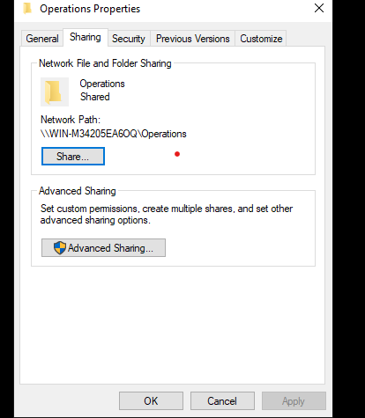

After we click on finish we can see our mapped drive in clinet machine, but this mapping network drive is not persistent.

Network sharing is more persistent than network mapped drive.

So we should create a GPO for regular access to the users on windows server.

Right click on Drive maps and create new mapped drive then add location and drive letter.

After that link the GPO to the appropriate organizational unit.

Lets test our GPO by login into the client machine.

We can see our Operations folder in client machine.

FRSM- File Server Resource Manager

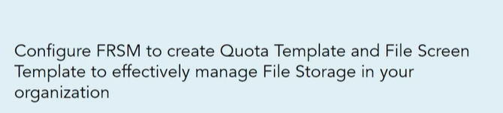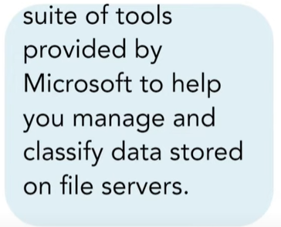

If we don’t have FSRM installed in our server, we need to install it by going into server manager.

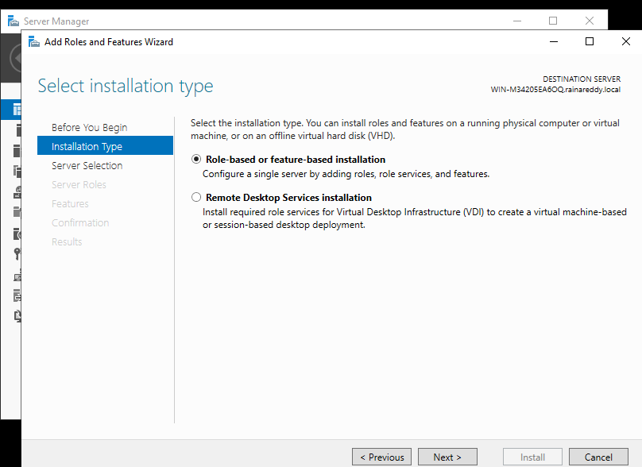

In file and storage services we need to choose File Server Resource manager and click next and click install.

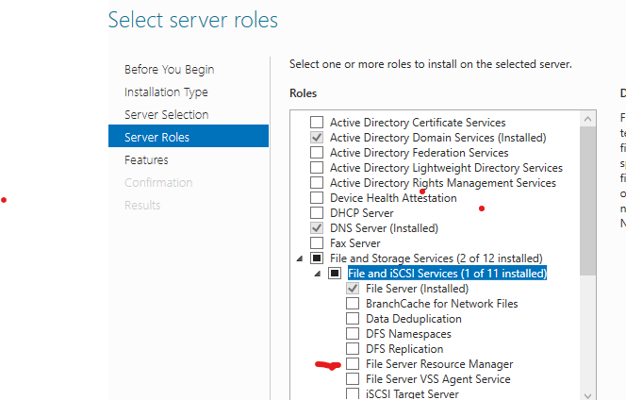now we can see it in our administrative tools.

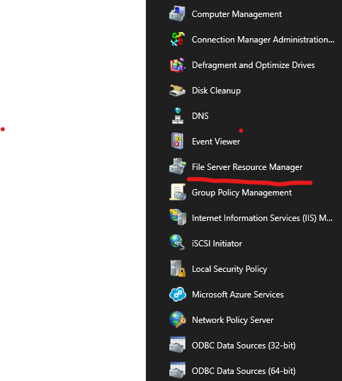this is how it looks from inside.

By using quota management, we can create a limit size for our shared folders.

We are creating quota path on shared folder by right clickingon quota. 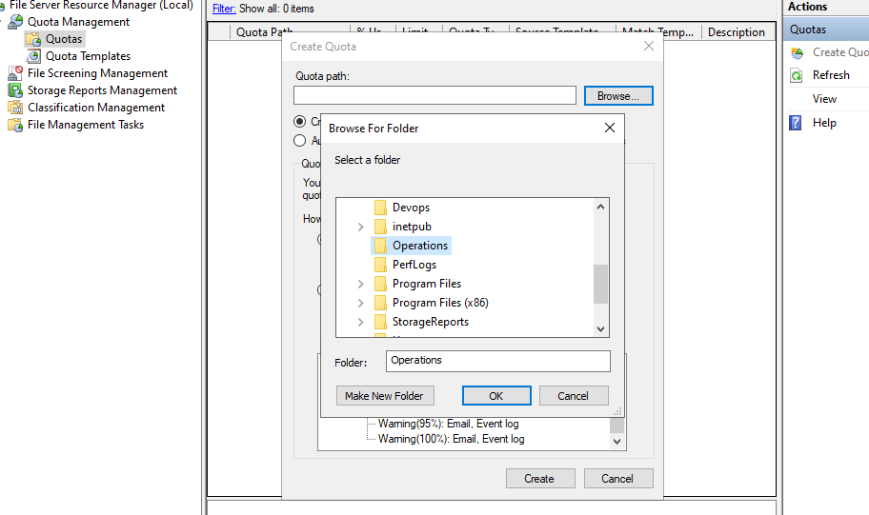

After path is selected click on custom properties to create limit. 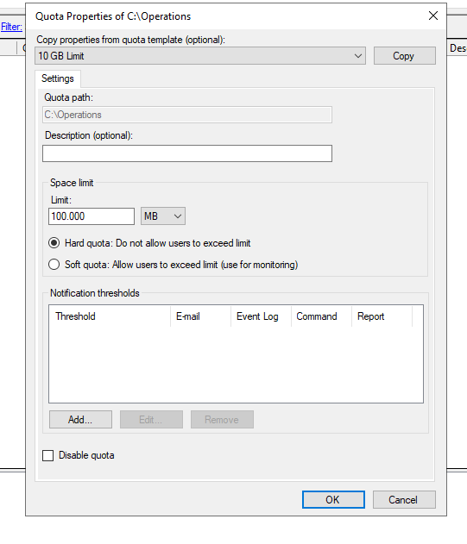



After that we can add notification threshold which alerts users and admins when the limit is exceeded. 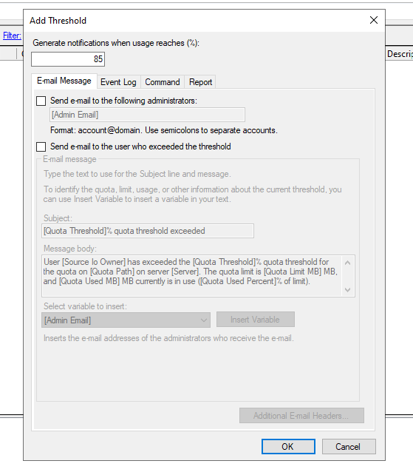we can choose option send an email to admin or user and click ok so that quota on path is created.

In the same way using file screening allows we can block the type of files we don’t want to accept. 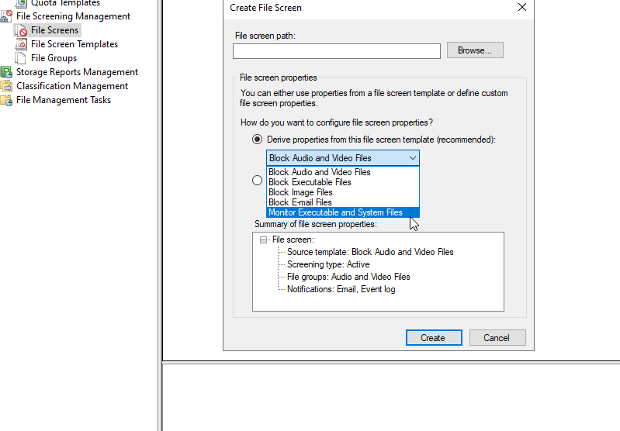

If we want to restrict more types of files we need to choose custom properties. 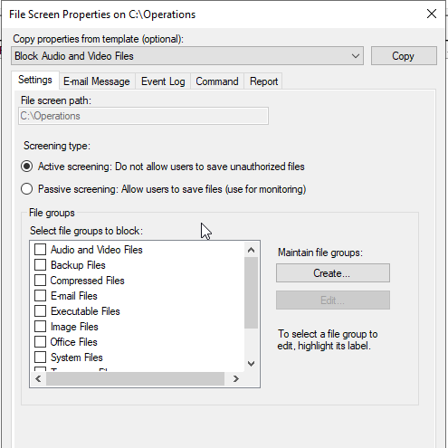

I selected audio and video files and created File screen path.

I downloaded an audio file and uploaded in the operations folder on which we set file screen persmission with audio and video block properties.

The resultin image shown below where our file screen restriction is successful

Next we are going to implement security policies with Fine Grained Passwords.

5. Implement Securtiy Policies | Fine Grained Passwords

In this activity I am going to create password policy with minimum password length, age and complexity.

In this digital age standard minimum password length is 12 characters.

We need to create a new group policy object. We are having a default password policy in group policy objects, so we are just going to edit it.

I enforce password history for 9 passwords to be remembered.

Complexity must always be enabled.

Let us test by login into one of the user through client machine.

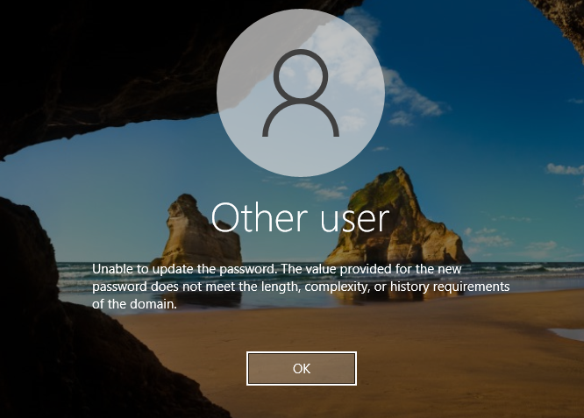

This is a good sign that our policy is working efficiently.

In the same way I configured account lockout policy in computer configuration and did testing on my client machine.

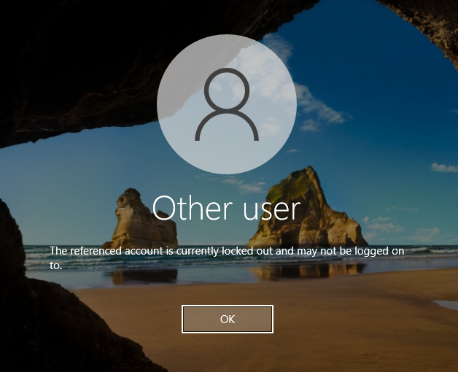



Next activity we are going to assign user rights and restrictions to enhance security.

Role Based access, conditional access and restricting users from admin access .

Create a new GPO in GPM named user rights and clcik on edit

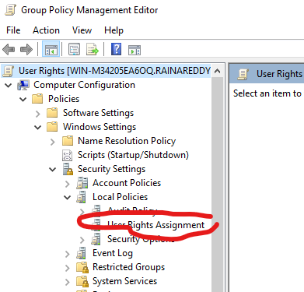

The next policy I configured is Allow logon through Remote Desktop Services

So now I am going to test them by signing out of the windows server.

Now I am signing in the server with a user account instead of admin account, I wil try a user from HR Europe group named daggubati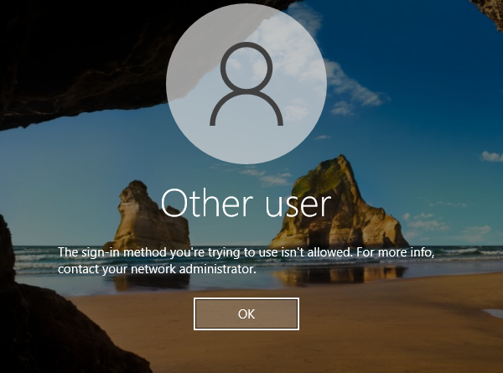

This implies our policy is working effectively.

Later I am going to test : Allow remote access desktop from Finance-Asia group, from an user named singh.

Our test resulted successful.

Next task is applying different policies to different users in windows server using Active Directory Administrative center instead of Group policy objects.

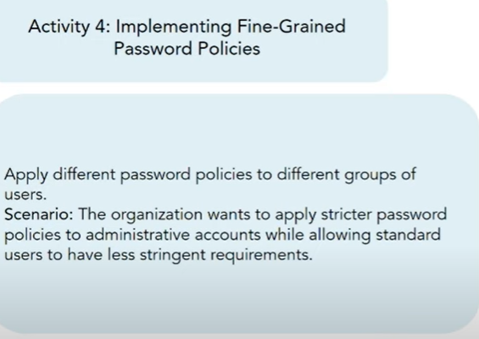

Lets create AdminPassowrdPolicy at the beginning.

The lowest precedence takes the priority.

Click to add Admins or group.

Creating one password policy for users.

Created password setting for users in finance-Asia group in Asia organisational unit.

In the end you can see two password policies we created in this administrative centers password container.

6. Implementing Service Accounts | Single Purpose Computers

\*\* user account is created for a person to use and service account is not for users, it is a computer that is designed to host a 24/7 service.

Now we need to setup a computer to host or display the specific web page.

Service account is going to be used as login account into a website and we need to restrict logon to service account.

We are now going to create a user named website login in service accounts.

Click next and configure website login account properties.

Now we need to download and install sysinternals in our client machine.

Extract it and find auto logon.

Username

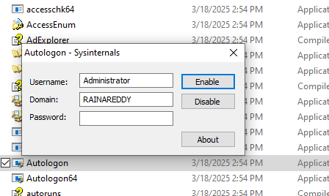

Username must be the name of service account we created named $Website-login.

After using the username and domain, password of service account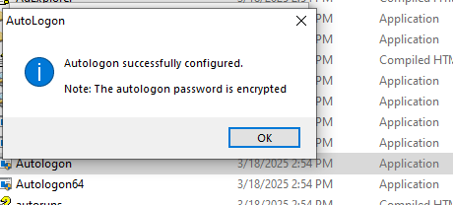

After rebooting the autologon was successful for client machine.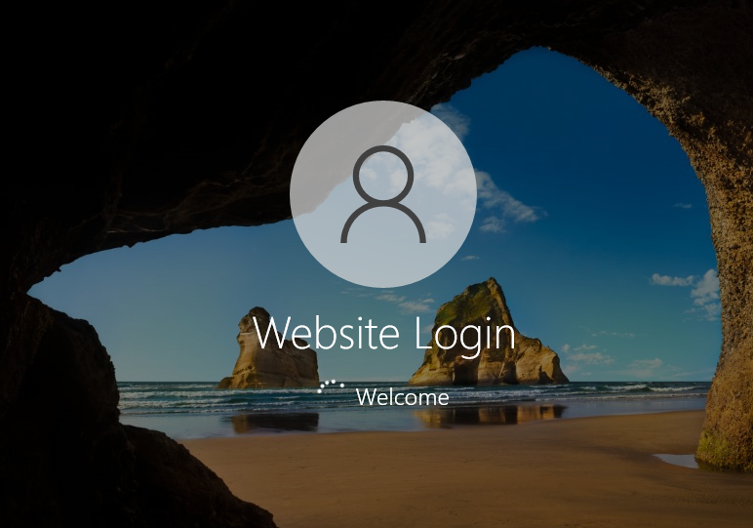

Now we are going to setup the browser to show the webpage we want to display whenever we opens the browser.

I am going to use the google chrome browser.

Click on settings then choose On startup

Click on add a new page.

Choose any random website url.

Click on add and close the browser to test whether the website is opening or not.

When I opened the browser the webpage started showing up.

We want to open it full screen so we are making some settings in chrome browser which is on desktop.

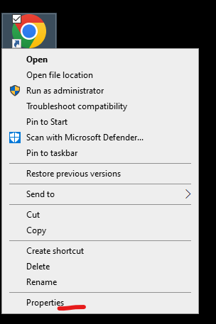

Click on properties and change the shortcut a bit.

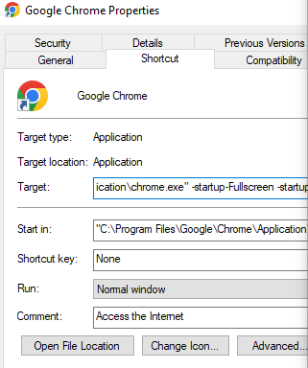

click on apply after extending the target URL with full-scrren extension.

After that it opens in full screen.

Add to startup programs, when system reboots the webpage should open automatically.

Windows+r and click ok

This window shows up and we can upload all programs that we want to open after the device is powered on.

I want webpage inside google chrome to open that’s why I am moving it here.

Next we need to set sleep settings to never otherwise this service account website will power off.

Once I restared the computer this time it opened the website automatically without the need of google chrome.

Now as we did in all above episodes we are going to create a gpo to restrict logon to service account in windows server.

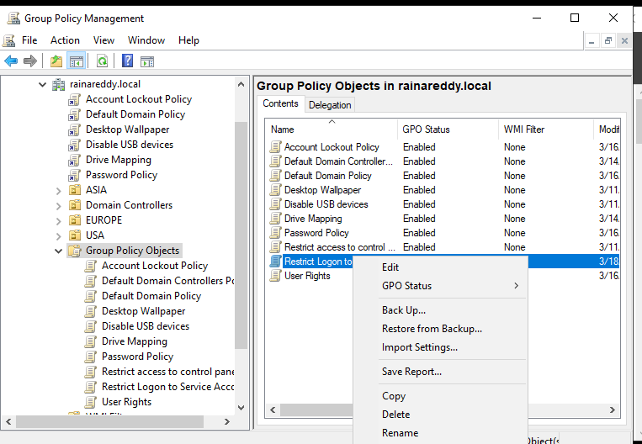

Computer Configuration.

We are configuring deny log on locally.

Added IT group in Deny log on locally policy.

Link the Restrict access to service account(GPO) to organisational unit in which IT group is

Now test our gpo by singing into client machine using a user account in IT group.

This gpo is successful.